Despite the Bugs - Good Progress Made! 🎯

While these bugs are critical, let's also recognize what IS working:

✅ Beautiful new wallet UI design

✅ Add Income/Expense dialogs functional

✅ Data is being saved to database

✅ Budget health visualization (95% ring)

✅ Proper categorization system

✅ Recurring transaction patterns

What's Working Well:
- ✅ Math is correct: 95,356 - 4,600 = 90,756 DKK ✓
- ✅ Currency stays in DKK (no more USD confusion)
- ✅ Beautiful visual design with budget health ring
- ✅ Income and expenses properly listed
- ✅ Next payment dates shown

Vision for Integration:
Calendar View:
- July 7: 💚 Salary (DKK 36,356)
- July 7: 💚 A Salary (DKK 50,000)
- July 7: 💚 Air BnB (DKK 9,000)
- July 7: 🔴 Rent (DKK 1,600)
- July 10: 🔴 Car Payment (DKK 3,000)
Transactions Page:
- Top banner: "Budget Remaining: DKK 90,756"
- As you spend, this number decreases
- Warnings if spending too fast
This will create a complete financial management system where everything is connected!

Celebrate Your Achievement! 🚀
You've successfully:
- Transformed a simple balance viewer into a cash flow management system
- Implemented flexible recurring transactions
- Created a visual budget health indicator
- Built the foundation for a comprehensive financial app
Once these final fixes are done, you'll have a professional-grade budget management tool!

The wallet is working well but needs these final fixes:
1. DROPDOWN OVERLAP - URGENT: The frequency dropdown covers the date input below Please add more spacing between ALL form fields Try: className="mb-6" on each FormItem wrapper
CALENDAR INTEGRATION: Open /src/app/dashboard/calendar/page.tsx Show the recurring transactions from wallet as calendar events: - Green dots/events for income - Red dots/events for expenses - Show on the dates they occur
-Callendar page not loading
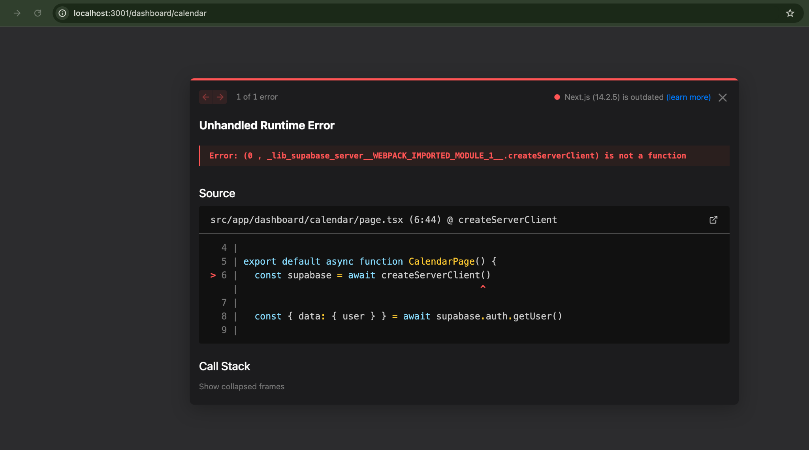

Transactions page not loading: TRANSACTION PAGE UPDATE: Show "Budget Remaining: DKK 90,756" at the top When users add transactions, subtract from this amount
